New Imperialism In China
In the second half of the 19th century, European countries, and sometimes the United States, embarked on a second and furious phase of Empire-building, known as New Imperialism. In contrast to the old colonialism of the 16th century, Imperialism 2.0 focused on Asia and Africa rather than Latin America. And unlike the Age of Discovery, New Imperialism was fuelled by industrialisation. France, for example, patched together the colony of Indochina, which included modern day Vietnam, Laos, and Cambodia. While the United States seized the Philippines, European countries competed over a scramble for territory in Africa. Although China never became a formal colony during this period, the British led the way in forcing the once proud Asian empire to open up its borders to trade. New Imperialism occurred during a short window of time—roughly 1840 to 1914—as European countries competed for territory to stake out formal and informal control of new regions.

The First Opium War (1838-1842)
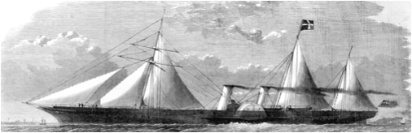
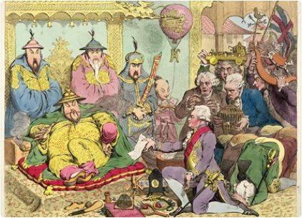
In the middle of the 19th century, the rising British Empire and the waning Chinese Empire went to war over drug addiction. In a sense, the two powerful countries took turns as drug pusher and addict. At first, the British were addicted to stimulating Chinese tea, which resulted in a trade imbalance because the Chinese bought few European products and demanded silver or gold in return. Because of this wealth sucking trade deficit, British merchants looked in vain for many years for some commodity that the Chinese would buy, until they finally found their answer in Indian opium from the province of Bengal. By the middle of the 19th century, thanks to Chinese addiction to Indian opium, silver flowed in surplus back to Britain. This greatly increased British prosperity and helped pay for the cost of running the colony of India. In short, much of British imperial success in the 19th century was based on hooking more and more Chinese to an extremely dangerous and addictive recreational drug.
China’s wealth and industrial production still dwarfed that of Great Britain at the end of the 18th century. So in 1798 when Lord Macartney won an audience with the Manchu (also known as Qing) Emperor, a bit of diplomatic gamesmanship ensued when the British ambassador refused to kowtow on his knees to the august emperor. Instead, Macartney brought manufactured trinkets, such as clocks, and a letter from his king, George III. He aimed to impress the emperor with the manufactured goods and win permission to trade with the Chinese beyond the designated city of Canton (now Guangzhou). The emperor, however, seemed uninterested and sent a dismissive reply to the British king: “Our ways have no resemblance to yours, and even were your envoy competent to acquire some rudiments of them, he could not transplant them to your barbarous land . . . Strange and costly objects do not interest me. As your Ambassador can see for himself, we possess all things. I set no value on strange objects and ingenious, and have no use for your country’s manufactures” (Beeching 17). Macartney’s mission largely failed. The emperor preferred to hold Europeans at a distance and limit foreign commerce to just one port of entry, but opium would soon work its way far past the designated trade city of Canton.
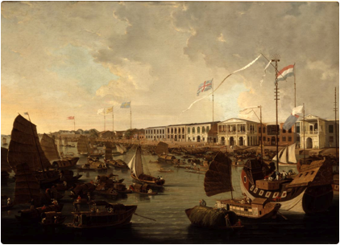
The lucrative and illegal opium trade spread rapidly in China in the early 19th century. Arabs had traded opium to China for centuries for use as a painkiller. Few used it as a recreational drug, however, because it tasted lousy when swallowed and was in short supply. Then a new smoking technique increased demand by making the drug more accessible and pleasurable to the user. The Chinese Manchu emperor declared an edict in 1799 that prohibited smoking or selling opium (Beeching 25). But the key ingredient, morphine, created a chemically addictive euphoric effect on its users. Just seven to ten days of smoking could leave the user addicted for life (Beeching 27). In 1819, the East India Company decided to increase the supply of cheaper opium from Bengal to undersell American and Persian opium dealers (Beeching 34). With almost no navy to enforce the drug ban, the Chinese government failed to stop the trade on the seas, especially since the wealthy opium merchants could afford to buy the fastest ships available. Between 1805 and 1839, opium imports into China increased more than one thousand percent, from 3,159 to 40,200 chests (Lovell 36). By the mid 19th century, Opium use permeated Chinese culture, even infecting generals and imperial guards.
In 1838, a Chinese official described the opium transformation throughout society:
“At the beginning, opium smoking was confined to the fops of wealthy families who took up the habit as a form of conspicuous consumption, even they knew that they should not indulge in it to the greatest extreme. Later, people of all social strata—from government officials and members of the gentry to craftsmen, merchants, entertainers, and servants, and even women, Buddhist monks and nuns, and Taoist priests—took up the habit and openly bought and equipped themselves with smoking instruments. Even in the centre of our dynasty—the nation’s capital and its surrounding areas—some of the inhabitants have also been contaminated by this dreadful poison” (Smith 36).
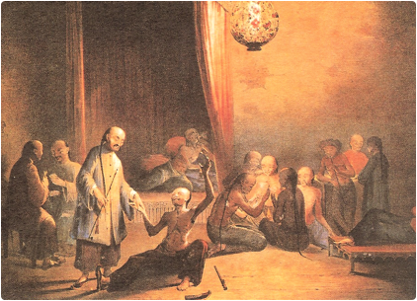
Finally, the emperor of the Manchu (Qing) Dynasty decided to stamp out opium once and for all. The imperial court understood that the trade debilitated their people and weakened the economy. One Chinese official commented that they were faced with a “life-destroying drug threatening to degrade the entire Chinese people to a level with reptiles, dogs and swine” (Lovell 21). Still, some Chinese officials wanted to legalise opium in order to tax it and trade it directly for tea so that silver wealth would not leave the country. But the emperor would have none of it. Instead, in 1838, he appointed a High Commissioner to eliminate opium by arresting opium addicts, dealers, growers, and merchants. The emperor wrote a letter to Queen Victoria of England: “There is a class of evil foreigner that makes opium and brings it for sale, tempting fools to betray themselves merely in order to reap profit. Formerly the number of opium smugglers was small; but now the vice has spread far and wide, and the poison penetrated deeper . . . We have decided to inflict very severe penalties on opium dealers and opium smokers . . . This poisonous article is manufactured by certain devilish persons in places subject to your rule . . . What is here forbidden to consume, your dependencies must be forbidden to manufacture . . . When that is done, not only will the Chinese be rid of this evil but your people too will be safe” (Beeching 76). The Queen did not reply, which did not bode well for the emperor’s plan.
The emperor’s High Commissioner, Lin, then confiscated opium in Canton and destroyed it, which quickly spiralled into a conflict between the British and Chinese governments. The British Superintendent of Trade in Canton was the highest-ranking official. Without permission or authority from his government, this official took it upon himself to promise British opium merchants that the British government would insure the value of all the opium that the Chinese government confiscated (Beeching 80). Suddenly, the British government was on the hook for the cost of a lot of illegal opium. Lin destroyed the 20,000 chests that the British merchants handed over (Lovell 69). The commissioner also demanded that the British opium traders sign a bond promising, on penalty of death, not to bring any more opium to China (Lovell 71). The British official refused to comply and so the foreigners were asked to leave China for good (Beeching 81). Meanwhile, on July 12, 1838, thirty British sailors on recreational leave in a village near Hong Kong, demolished a temple and killed a Chinese civilian. Lin demanded the British release the murderer to Chinese authorities, but the British refused, citing extraterritoriality, which means that British citizens cannot be tried in foreign courts (Beeching 88). So Lin then blockaded the British fleet and refused them food, water, and trade until they handed over the murderer and promised not to sell the poisonous drug (Lovell 8). The British official still refused to stop the illegal opium trade and, instead, gave the Chinese a deadline to lift the blockade. When the deadline passed, the British fired on Chinese junks, but the short battle ended in a stalemate because the British navy had not yet arrived. The First Opium War had begun, started by a British Superintendent of Trade’s support for the illegal opium trade.
Thousands of miles away in the London, Parliament debated whether they should go to war over the opium trade or back down from the conflict. Under pressure from British merchants and nationalists, some members of Parliament favoured the war. Thomas Macauley, the Secretary of State for War, argued in parliament, “I beg to declare my earnest desire that this most rightful quarrel may be prosecuted to a rightful close . . . that the name not only of English valour but of English mercy may be established” (Beeching 109). William Gladstone, a member of Parliament who had tried and failed to cure his sister of opium addiction, responded to Macauley’s flag waving speech by focusing on the high moral ground:
“Does [Macauley] know that the opium smuggled in to China comes exclusively from British ports, that is, from Bengal and through Bombay? . . . That we require no preventive service to put down this illegal traffic? We have only to stop the sailing of the smuggling vessels . . . it is a matter of certainty that if we stopped the exportation of opium from Bengal and broke up the depot at Lintin and checked the cultivation of it in Malwa and put a moral stigma on it we should greatly cripple if not extinguish the trade in it. They [the Chinese] gave you notice to abandon your contraband trade. When they found you would not do so they had the right to drive you from their coasts on account of your obstinacy in persisting with this infamous and atrocious traffic . . . justice, in my opinion, is with them; and whilst they, the Pagans, the semi-civilised barbarians, have it on their side, we, the enlightened and civilised Christians, are pursuing objects at variance both with justice and with religion . . . a war more unjust in its origin, a war calculated in its progress to cover this country with a permanent disgrace, I do not know and I have not read of. Now, under the auspices of the noble Lord, that [British] flag is become a pirate flag, to protect an infamous traffic” (Beeching 110).
Despite Gladstone’s famous speech in opposition to the war, Parliament approved military intervention in China by a vote of 271 to 262 (Beeching 111). There seemed to be a larger issue at stake beyond the pretext of free trade. The Lord of the Admiralty wrote enthusiastically to a friend in a private letter, “Afterall, it is nothing more nor less than the conquest of China we have undertaken” (Beeching 98).
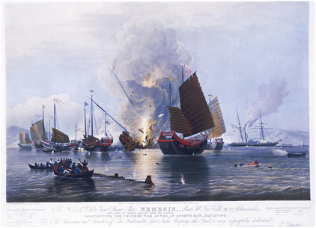
As the war proceeded, British advanced military technology made easy work of outdated Chinese defences. British rifles and cannons were far more deadly, and had a longer range, than their Chinese counterparts of swords, spears, old muskets and ancient cannons. The British also commissioned a new steam ship, the Nemesis, which baffled and shocked the Chinese soldiers. With its shallow bottom, it moved up the Pearl River towards Canton during low or high tides, and regardless of the direction of the wind. Its impenetrable iron sides rebuffed all assaults, and its powerful and accurate canons easily demolished Chinese defensive walls. In the first day of the naval battle at the fort at the mouth of the Pearl River, the Chinese lost 280 dead and 462 wounded (Lovell 132). The British, in contrast, suffered zero losses (Lovell 133). As similarly lopsided victories mounted throughout the war, British military superiority increasingly demoralised Chinese armies. Chinese officials, however, continued to underestimate the importance of British technology.
The Chinese blamed their overwhelming losses on their own poor leadership or the lack of local support. The Imperial Commissioner appointed by the emperor blamed the local people in the Canton region for their lack of support of the Manchu government: “The trouble lies within, not without, because every merchant has got rich through the foreigners, and even the lowest orders make their living from them. All the merchants and people who live near the coast are fluent in the foreigners’ language” (Lovell 149). The Emperor repeatedly changed the High Commissioner in charge of prosecuting the war as defeat followed defeat. But no Chinese general could respond effectively to British military superiority. One Imperial Commissioner insisted on fighting the British on land because he thought the Europeans could not “use fists or swords. Moreover, their waists are stiff, and their legs are straight. Once fallen down they cannot get up again” (Lovell 185). At the battle of Ningpo this same commissioner witnessed 500 of his soldiers die while the British again suffered no losses; after yet another devastating defeat, he killed himself by swallowing a lethal dose of opium (Lovell 190 and Beeching 146).
The disgraceful military defeats were less shameful than the final peace agreement. The Treaty of Nanking, signed on August 29, 1842, humiliated the Chinese. The British insisted that four more city ports be opened to trade, which would surely increase the illegal opium trade. In addition, the Chinese agreed to pay a huge indemnity equal to half of all government revenues for a year, and it had to be paid in silver (Beeching 154-5). To their credit, the Chinese refused to even discuss the legality of the opium trade. They could have gained huge revenue by taxing the drug. The Emperor said in 1842, however, that no defeat would convince him to legalise opium: “Gain-seeking and corrupt men will for profit and sensuality defeat my wishes, but nothing will induce me to derive a revenue from the vice and misery of my people” (Beeching 156). The British, for their part, proclaimed that they would not support or defend opium merchants or pirates. The Chinese commissioner who signed the treaty asked the emperor to punish him as a matter of honour—he was banished as a common convict. Both the British and the Chinese would find ways to squirm out of the key provisions of the treaty. The British did nothing to stop the opium trade and the Chinese refused to let Europeans stay year round to establish residence in Canton. Taking advantage of the degrading defeat, the French and Americans quickly made favourable treaty arrangements with China. The imperial vultures were descending on the moribund Chinese Empire.
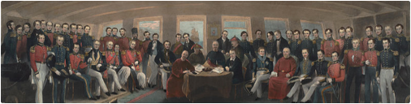

The Taiping Rebellion (1850-1862)
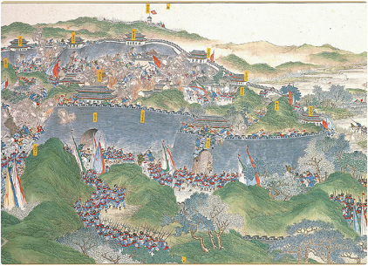
As if a humiliating foreign conquest was not enough, the Chinese government had to then contend with a massive uprising from within. The Taiping Rebellion from 1850 to 1862 was a reaction to the corruption and weakness of the Manchu dynasty. “Taiping” or “great peace” referred to an ideal time when the leaders would be moral and the people would be happy (Beeching 183). The Taiping founder, who had studied with a European priest, believed that God told him he was the younger brother of Jesus Christ (Lovell 45). At a time when canals were dilapidated and aspiring candidates could buy their way into coveted government positions, the Taiping rebels sought to renew and purify China through a local brand of Christianity. The Taiping forbid opium smoking, gambling, theft, and private wealth. Then they recruited and trained a fervent army and repeatedly defeated government troops in battle. 500,000 strong by 1853, the rebels made Nanking (Nanjing) their capital before they marched 1400 miles to challenge the Manchu government in the capital of Peking (Beijing) (Beeching 188). The government now had two Christian enemies—the European Christians and the Taiping rebels. The Manchu government barely defeated the Taiping uprising. Though “Taiping” means “great peace,” the civil war was extremely bloody, possibly the bloodiest in world history—at least twenty million lost their lives (Beeching 180). And it showed for all to see that the Manchu dynasty had a tenuous grip on their country.

The Second Opium War (1856-1860)
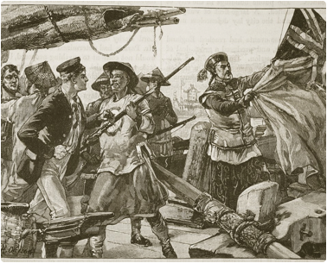
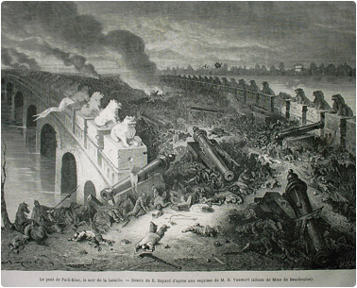
The Second Opium War began in 1856 for reasons just as petty as the first war. The Chinese had still not allowed the British to enter the city of Canton—though they allowed them to trade outside the city walls—because of a disagreement over the translated language in the Treaty of Nanking. Despite protests, the Chinese held firm on this and the inconvenience and indignity rankled the British. One day Chinese police boarded an improperly registered British boat (that did not have the required British flag flying) and took twelve Chinese citizens into custody, including three well-known pirates that the British merchant had hired. The British official complained that the Chinese were not allowed to board a British boat and the men were returned. But, seeing an opportunity to push the thorny issue of foreigners being banned from entering the city of Canton, the British officer demanded a written apology. When the Chinese refused, British gunboats opened fire on Canton starting the Second Opium War (Beeching 217). The real reason for the British reopening the war was that they wanted to force a more favourable revision of the Treaty of Nanking, and this time the French and Japanese piled on.
Just as in the First Opium War, European military technology proved too much for the Chinese. The British quickly destroyed the Chinese fleet at Canton and took the city. Some Chinese generals thought that they could beat the combined British and French forces if they lured them inland away from their indomitable gunboats. But European forces crushed the Chinese forts and inland armies with superior fire-power and moved to Peking. The young, scared Emperor fled to a hunting lodge a hundred miles north of the capital.
The prince who was left in charge to defend Peking took foreign ambassadors hostage when they came to negotiate. French and British armies numbered only 3500 against 20,000 Chinese soldiers (Beeching 300). Europeans had cavalry, disciplined professional soldiers, and the new breach loading Enfield rifles. In contrast, the Chinese used cavalry armed with bows and arrows. In one major battle there were 35 European casualties to 1500 Chinese (Beeching 305).
When the British and French forces arrived in Peking, they looted and destroyed the most precious royal treasure. The Summer Palace was an amazing eighty square miles of meticulously planned park, buildings, and artistic treasures, including gold, silver, jade, silk, and ancient royal robes and thrones. The French and British troops plundered it all (Beeching 316-318). Ironically, the thousands of looters missed the biggest prizes, perhaps because they were hiding in plain site—two enormous lion statues that were assumed to be cheap brass were actually solid gold (Beeching 321). After the looting, the European armies burned down the Summer Palace. New treaties forced China to open up to more free trade and Christian missionaries.
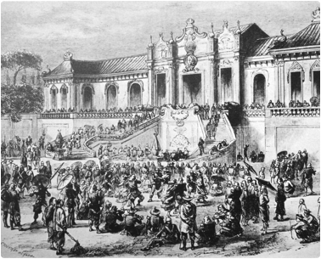

The Legacy of the Opium Wars
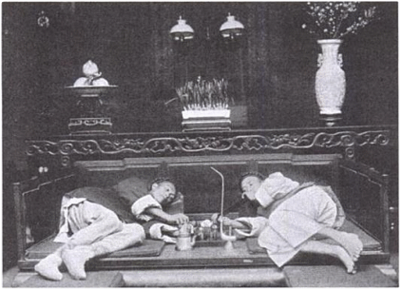
As a result of the Opium Wars, European control of China increased, the Manchu further lost the respect of its people, and rebellions continued. Opium came to be identified within China with all that was wrong with the Manchu ruling class. By 1864, eighty percent of Chinese trade was with Britain, and opium exports from India to China doubled from 1860 to 1880 (Beeching 330-331). The Chinese nation was humiliated by European imperial control and also by defeat in war with the much smaller but more industrialised Japan in 1895. All this led to another uprising.

The Boxer Rebellion (1898-1901)
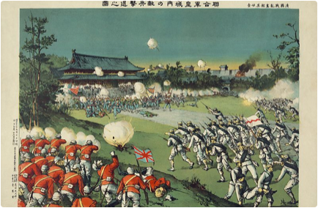
In response to the national humiliation of losing wars to Japan and the European imperial powers, another uprising occurred that aimed to purify China of foreign cultural, economic, and political influence. These rebels, known as the Boxers, wanted to return Chinese culture to its conservative Confucian values, such as respect for elders, ancestors, family, and the emperor. The Boxers sought to rid China of all westerners and the influence of their Christian religion.
The rebels became known as the Boxers because they publicly demonstrated a type of spirit possession in which groups of people would invite Gods to embody them as they performed martial arts fighting exercises. They claimed that these spiritual trances rendered them invulnerable in fighting. The public martial arts displays helped them recruit new members—they also helped them became known as the Boxers. A former Boxer explained how he trained as a young man: “When we took up Spirit Boxing . . . we requested the gods to attach themselves to our bodies. When they had done so, we became Spirit Boxers, after which we were invulnerable to swords and spears, our courage was enhanced, and in fighting we were unafraid to die and dared to charge straight ahead” (Cohen 96).
Poor living conditions and natural disasters also increased Boxer recruitment. The experiences of drought and flood in 1899-1900 made people desperate for a solution to their problems. An American Christian minister wrote about the ripe environment for recruitment in 1900: “The people are very poor; until yesterday, practically no rain has fallen for nearly a year, plowing has not been and can not be done, crops have not been planted, the ground is too dry and hard to work in any way, and consequently the whole country is swarming with hungry, discontented, hopeless idlers, and they are ready to join any organisation offered” (Cohen 82-83). The Boxers believed foreign intervention caused these natural disasters.
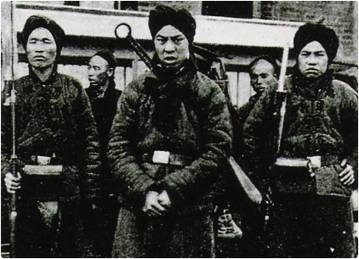
The Boxers blamed Christianity, in particular, for the ills that plagued China. One public notice posted in a town in 1899 showed how the rebels targeted Chinese converts to Christianity: “The gods of happiness and wealth issue these instructions for the information of the members of the Catholic and Protestant religions: You have abandoned the gods and done away with your ancestors, causing the gods to be angry so that the rains do not fall from the sky. Before long heavenly soldiers and heavenly generals will descend to earth and wage a great battle with the adherents of your two religions. It is a matter of great urgency that you quickly join the Boxers and sincerely mend your ways, so that when the time comes for the great battle, your entire families do not suffer harm” (Cohen 86). After such warnings, the Boxers harassed Chinese Christians, sometimes destroying their churches or burning down their houses. The largest amount of Chinese Christian converts— over 100,000 —lived in the area of Peking (Cohen 36). Not surprisingly, the Boxers grew strongest near the capital where there were also the most foreign diplomats, missionaries, telegraphs and railroads.

As the Boxers grew in number, popular songs about them spread from village to village. This example shows the emphasis the rebels placed on traditional Chinese values and the need to expel the foreigners:
Divinely aided Boxers,
United-in-Righteousness Corps
Arose because the Devils
Messed up the Empire of yore.
They proselytize their sect,
And believe in only one God,
The spirits and their own ancestors
Are not even given a nod.
Their men are all immoral,
Their women are truly vile.
And if you don’t believe me,
Then have a careful view:
You’ll see the Devil’s eyes
Are all a shining blue.
No rain comes from Heaven.
The earth is parched and dry.
And all because the churches
Have bottled up the sky.
The gods are very angry.
The spirits seek revenge...
En masse they come from Heaven
To teach the Way to men.
Gods come down from the hills,
Possessing the bodies of men,
Transmitting their boxing skills.
When their marital and magic techniques
Are all learned by each one of you,
Suppressing the Foreign Devils
Will not be a tough thing to do.
Rip up the railroad tracks!
Pull down the telegraph lines!
Quickly! Hurry up! Smash them—
The boats and the steamship combines.
The mighty nation of France
Quivers in abject fear,
While from England, America, Russia
And from Germany naught do we hear.
When at last all the Foreign Devils
Are expelled to the very last man,
The Great Qing, united, together,
Will bring peace to this our land
(Smith 122-123).
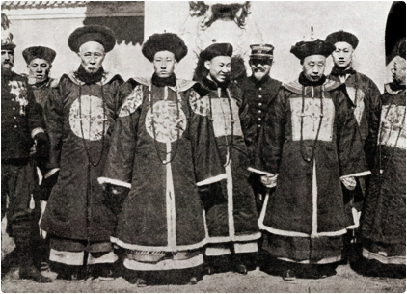
After initially resisting the uprising, the Manchu Dynasty eventually supported the Boxers. The movement was popular but also unruly, so the Chinese court vacillated in deciding how to respond. Even though the Boxers supported the Manchu (Qing) Emperor, the Chinese government at first executed key Boxer leaders in 1898. New leaders quickly emerged, however, and the movement became even more popular. The rebellion inevitably spun towards chaos; for example, one mob of Boxers massacred thirty Catholic families in a village near the capital (Cohen 46). They also killed several western missionaries, targeted foreign diplomats in Peking (Beijing), and ripped up railways and telegraph lines. By the time the Chinese government fully supported the uprising, foreign powers had agreed to intervene to prevent further mistreatment of their citizens. The Boxers and government troops fought together against mostly Russian and Japanese troops at the battle of Tianjin. The Chinese lost against more industrialised armies. Just as during the Opium Wars, the foreigners won victory after victory. The Emperor fled. In the end, a couple hundred foreigners and thousands of Christian Chinese were murdered (Cohen 51). But, the Boxer rebellion that sought most of all to kick out the foreigners had, ironically, the opposite effect.
The victorious foreigners had the last word. They forced the Manchu court to agree to yet another humiliating treaty in 1901. The Boxer protocol, as it was called, expanded foreign presence and power in China. It stipulated that the government had to kill or exile key leaders in the imperial court who favoured the rebels. The Chinese had to destroy important defensive forts so that future foreign military intervention would be even easier. The treaty also banned China from importing weapons for two years, enlarged the foreign guard stationed in Beijing to protect foreigners, and allowed the permanent presence of foreign troops between Beijing and the coast. And, of course, the protocol forced China to pay a huge indemnity. The disgraced and ineffectual Manchu Dynasty was, not surprisingly, finally overthrown in 1911, just ten years after the treaty (Cohen 56).

The Legacy of New Imperialism In China
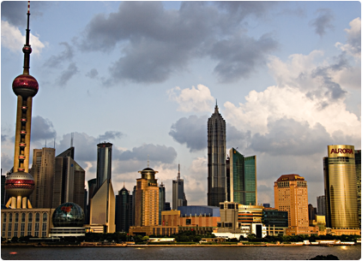
Chinese textbooks in the 21st century teach school children about the sense of gouchi, or national humiliation, in the 19th century: from the Taiping Rebellion to the Opium Wars to losing the war with Japan to the Boxer rebellion. The legacy of foreign imperialism continued into the 20th century. As late as the 1930s, ten percent of the population—50 million people—were still addicted to opium (Lovell 324). British control of one port city lasted 150 years. The British refused to return the colony of Hong Kong—seized during the First Opium War—to China until 1997. In the early 21st century, the tense issue of looted antiquities remained unresolved. In 2010, 150 years after British and French troops looted the Imperial Summer Palace, the Chinese government asked that over 1.5 million precious artifacts stolen from the Manchu Dynasty be returned (BBC). So far, the old imperialist countries have refused to give up the loot, and some of the most valuable Asian art in the world remains in British and French museums.

